QUES 1:
1. Frontend Development (Client Side)
Frontend is everything the user sees and interacts with on a website or app. It’s the user interface (UI) part — buttons, forms, text, images, layout, etc.
Main technologies:
- HTML (structure)
- CSS (styling)
- JavaScript (interactivity)
- Frameworks: React, Angular, Vue.js
Example (Real World):
When you open Amazon, the homepage, product search bar, Add to Cart button, and checkout page layout are all part of the frontend.
Frontend developers make sure it looks good and works smoothly on all devices.
2. Backend Development (Server Side)
Backend is what happens behind the scenes — it handles data, logic, and communication between the frontend and the database.
Main technologies:
- Languages: Python, Java, Node.js, PHP
- Databases: MySQL, MongoDB, PostgreSQL
- Frameworks: Django, Express.js, Spring Boot
Example (Real World):
When you log in to your Amazon account, the backend verifies your email and password with data stored in the database.
It also processes your order and updates the inventory — all invisible to you but essential.
3. Full-Stack Development
Full-stack developers work on both frontend and backend — they build the entire web application, from user interface to database.
Skills Needed:
- Frontend (HTML, CSS, JS, React/Vue)
- Backend (Node.js, Django, etc.)
- Database (MySQL, MongoDB)
- APIs, authentication, deployment
Example (Real World):
A small startup might hire one full-stack developer to build a complete food delivery website:
- Frontend: Menu display, cart, checkout UI
- Backend: Order storage, restaurant management, delivery tracking
- Database: Stores user info, orders, and menu items

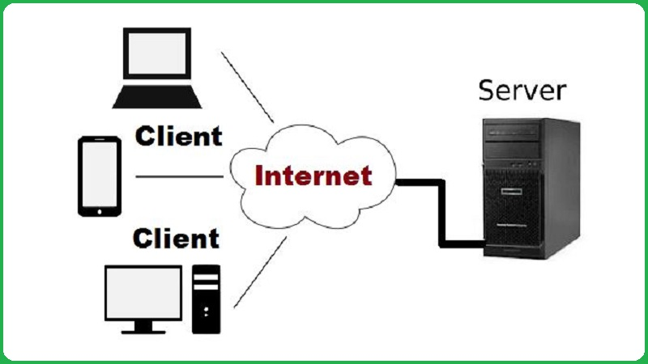
QUES 2:

How It Works
- Client (User) sends a request → e.g., “Show me the homepage”.
- Web Server receives it and processes it using backend code.
- If data is needed, the server queries the database.
- The database sends data back to the server.
- The server returns the processed result (webpage, data, etc.) to the client.
- The client’s browser displays it to the user.

QUES 3:
1.You enter a URL in the browser (e.g., www.example.com).
2. The browser performs a DNS lookup to find the IP address of the web server.
3. It then connects to the server using HTTP or HTTPS.
4. The browser sends an HTTP request asking for the web page (like index.html).
5. The web server processes the request and sends back an HTTP response containing HTML, CSS, JS, and other resources.
6. The browser reads the HTML, builds the DOM, loads CSS for styling, and runs JavaScript for interactivity.
7. Finally, the browser displays the complete web page on your screen.

QUES 4:
Tools Required to Set Up a Web Development Environment
- Code Editor / IDE
- Example: Visual Studio Code (VS Code), Sublime Text, Atom
- Purpose: Used to write, edit, and organize HTML, CSS, and JavaScript code.
It provides syntax highlighting, debugging, and extensions to make coding easier.
2. Web Browser
- Example: Google Chrome, Mozilla Firefox, Microsoft Edge
- Purpose: Used to view and test websites.
Built-in developer tools help inspect elements, debug errors, and analyze performance.
3. Version Control System
- Example: Git
- Purpose: Tracks changes in code, helps manage different versions, and allows multiple developers to collaborate safely.
4. Remote Repository Hosting Service
- Example: GitHub, GitLab, Bitbucket
- Purpose: Stores project code online and enables collaboration using Git.
5. Local Web Server / Runtime Environment
- Example: XAMPP, WAMP (for PHP) or Node.js (for JavaScript)
- Purpose: Runs and tests web applications locally before deploying them online.
6. Package Manager
- Example: npm (Node Package Manager), yarn
- Purpose: Installs and manages external libraries, frameworks, and dependencies used in web projects.
7. Browser Developer Tools
- Example: Chrome DevTools, Firefox Developer Tools
- Purpose: Used to inspect HTML/CSS, debug JavaScript, and monitor network requests.
8. Frameworks / Libraries (Optional)
- Example: React, Angular, Vue.js (Frontend) or Express.js, Django, Laravel (Backend)
- Purpose: Provide ready-to-use structures and reusable code to speed up development.
9. Database Management System (DBMS)
- Example: MySQL, MongoDB, PostgreSQL
- Purpose: Stores and manages data used by web applications.
10. Deployment Tools / Hosting Platforms
- Example: Netlify, Vercel, GitHub Pages, Heroku
- Purpose: Used to publish and host websites or web applications online.
11. API Testing Tools
- Example: Postman, Insomnia
- Purpose: Used to test APIs and backend services to ensure correct data exchange.
12. Design / Prototyping Tools
- Example: Figma, Adobe XD, Canva
- Purpose: Used to create UI/UX designs and website mockups before development.

QUES 5:
Web Server
- A web server is software or hardware that stores, processes, and delivers web pages to users through a browser.
- It uses HTTP or HTTPS protocols to communicate between the client (browser) and the server.
- It stores website files (HTML, CSS, JS, images, etc.).
- It handles client requests and sends responses (web pages) back to the browser.
- It can also run server-side scripts (like PHP, Node.js, or Python).
Examples of Common Web Servers:
- Apache HTTP Server
- Nginx
- Microsoft IIS
- LiteSpeed
- Apache Tomcat
- Node.js

QUES 6:
Roles in a Project
1. Frontend Developer
- Responsible for the visual and interactive part of a website or application.
- Works on the user interface (UI) and user experience (UX) using technologies like HTML, CSS, and JavaScript.
- Ensures the design is responsive, attractive, and easy to use.
- Example: Designing forms, buttons, layouts, and navigation menus that users see on screen.
2. Backend Developer
- Handles the server-side logic and functionality of the application.
- Works with server, APIs, and databases to process user requests.
- Uses languages like PHP, Python, Java, or Node.js.
- Ensures data is stored, retrieved, and processed securely.
- Example: When a user logs in, the backend verifies their credentials and sends data to the frontend.
3. Database Administrator (DBA)
- Manages the database system where all project data is stored.
- Responsible for creating, maintaining, and securing databases.
- Ensures data integrity, backup, and performance optimization.
- Uses tools like MySQL, Oracle, MongoDB, etc.
- Example: Monitoring database performance and restoring data in case of system failure.
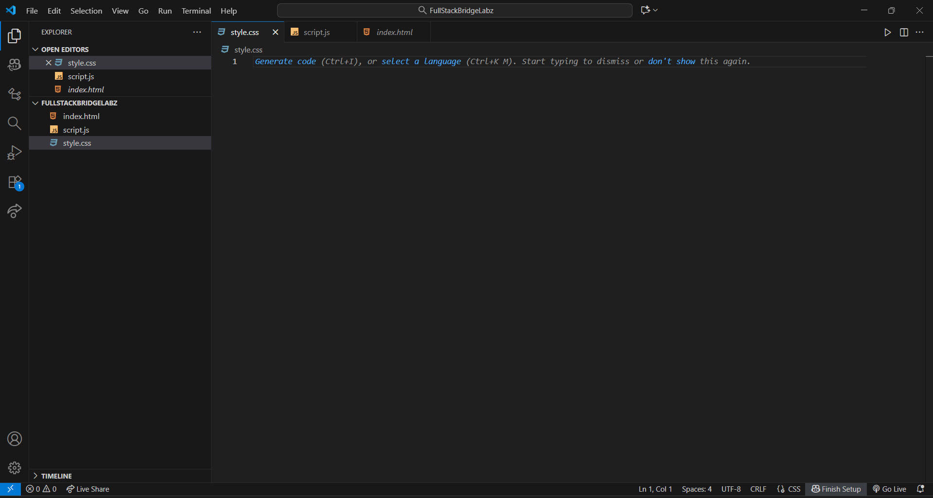
QUES 7:

QUES 8:

Difference Between Static and Dynamic Websites
Feature | Static Website | Dynamic Website
- Definition | A static website displays fixed content for every visitor. | A dynamic website displays content that can change based on user interaction or data.
- Content | Same for all users; does not change unless the developer updates it manually. | Different for different users; generated automatically from a database or server.
- Technology Used | Built using HTML, CSS only. | Built using HTML, CSS, JavaScript, and server-side languages like PHP, Python, etc.
- Database | No database connection. | Connected to a database (e.g., MySQL).
- Speed | Loads faster because of simple content. | Slightly slower because it fetches data from the server.
- Example | A company’s portfolio website or a personal resume page. | Facebook, Amazon, or Online Banking portals.

QUES 9:

Five Web Browsers and Their Rendering Engines
- Google Chrome – Uses Blink engine → Fast, modern, supports latest web standards.
- Mozilla Firefox – Uses Gecko engine → Open-source, highly standards-compliant.
- Apple Safari – Uses WebKit engine → Optimized for Apple devices.
- Microsoft Edge – Uses Blink (earlier EdgeHTML) → Chromium-based, fast and secure.
- Internet Explorer – Uses Trident engine → Older engine, limited modern support.

Differences in Rendering Engines
- Performance: Speed and memory usage vary across engines.
- Standards Support: Some engines support newer HTML/CSS/JS features better.
- Compatibility: Websites may look slightly different in each browser.
- Security: Modern engines (Blink, Gecko) get frequent updates.
- Platform Integration: Some engines (like WebKit) are optimized for specific OS (e.g., macOS).

- Examples:
Blink (Chrome/Edge) → Fast
Gecko (Firefox) → Open & standard
WebKit (Safari) → Apple-focused
Trident (IE) → Outdated

QUES 10:

